**1. Ware argues that human perception involves 2.5 dimensions. Given this assertion, when might a 3D visualization be useful and why?**

A 3D visualization would be useful when it would be relevant to see more aspects of a certain topic. To visualize a molecule and being able to watch the structure in multiple angles could be an e.g..

2. **In Chapter 6, Ware presents some implications of pattern recognition and visual working memory on design. Provide an example that harnesses some of these principles (perhaps an advertisement, visualization, or interface) and discuss how the design takes these principles into account. Please include a screenshot, photo, or website URL.**



In this advertisement of Coca Cola, there is immediately a certain kind of happiness expressed. This is because of light from the sun and the green fields.

But the part that attracts most of the attention is the bottle. That is because of the colour. The advertisement gives it a fresh look with the water drops on the bottle

There is a sort of attention-guiding mechanism that is called working memories. This mechanism let you first look at the bottle and after that gives you a happy feeling when looking to the right side of the advertisement.

3. **According to Bostock et. al., what are the primary advantages of D3? Based on your reading of the article, please provide an example of a type of visualization that would be easier and better implemented in D3 as opposed to HTML5, JSON, and Javascript. Please list the pros and cons of choosing D3 over pure HTML5, JSON and Javascript.**

Three pros of D3 are a better compatibility, better debugging and better performance. A disadvantage is that D3 is that for large numbers of entries it might be slow.

**4 . Of the visualization figures presented in Heer et. al., which do you find the most difficult to comprehend? Does the complexity of the figure interfere with the goal of visualization as described in the article? Include a screenshot of the figure you have chosen in your response and use principles that you have learned so far (i.e., from design, perception, and cognition) to justify your choice.**

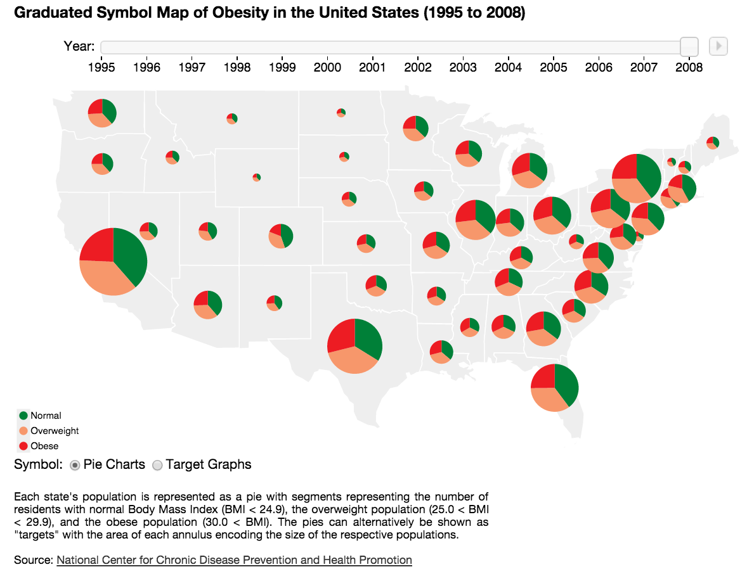

In my opinion this is the worst visualization. First of all the visualization does not give a quick and clear overview. It takes very long to interpret the data. Besides that, in this way of presenting the data there is no clear difference viewable between the states. Another con is that the circles overlap each other at some places.

**5. Play around with the interactive graphs included in the Heer article. You need to open this page in a browser that runs Java. Focus on Figure 1A. To what extent do interactivity and transitions, elements that D3 optimizes, add to the clarity and message of the visualization? With the element of interactivity in mind, redesign and sketch the contents of figure 1A with one of the other visualization types described in the Heer article. Include a picture of a sketch of your idea, and describe how it supports comprehension and data exploration.**

I would add another graph on the right of graph 1A another graph, which shows the value of each stock. This would be a nice addition because one now can only see the growth and loss, and not see the actual stock value